**Assignment: Doubly Linked List Implementation in C#**

**Part 1**

Objective: Implement a doubly link list using Generics in C#.

Instructions:

1. Implement a Node class to represent each node/item in the list
2. Implement a DoublyLinkList class with the following methods.
   1. AddFirst: Add to the head of the list.
   2. AddLast: Adds to the tail of the list.
   3. Remove: Removes a node/item from the list (remove from head)
   4. Display: Displays the elements of the list.
3. In the main method test out the DoublyLinkList using value and reference types.
4. Do not use any .NET collection and array in your solution

Expected Output using value types

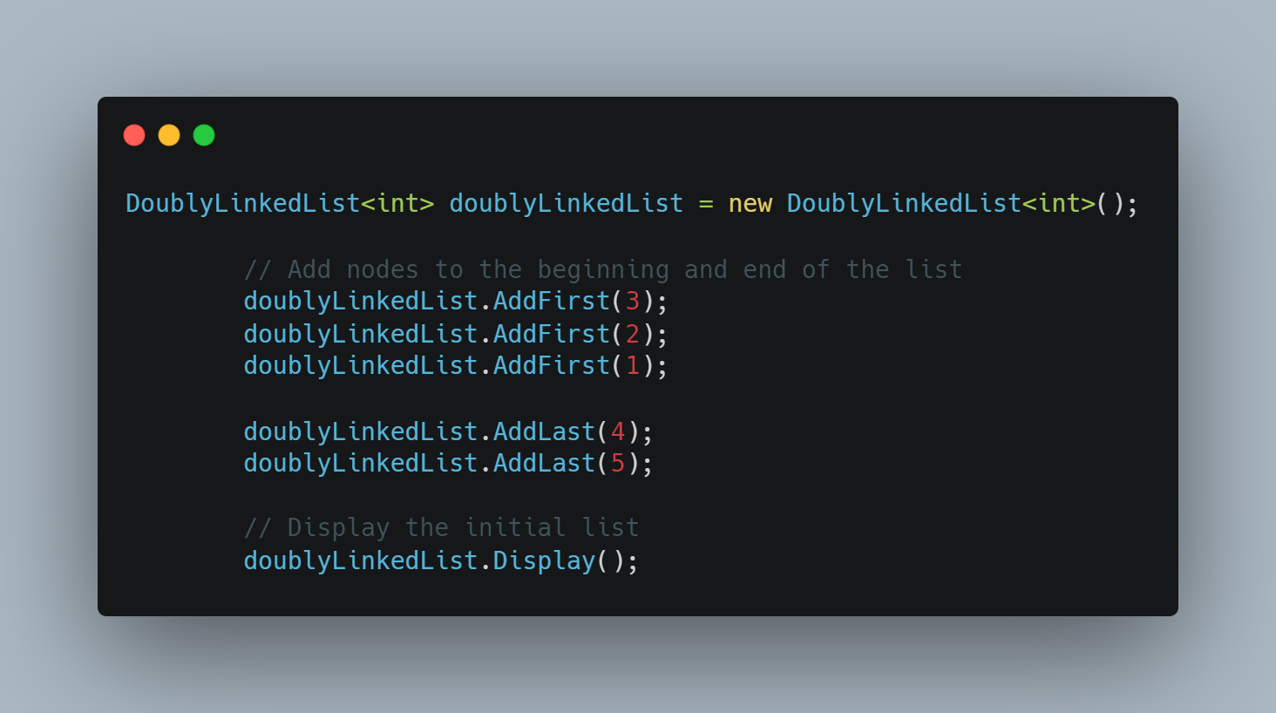

**Part 2**

Extend the above to add events. There will be 2 events in the DoublyLinkList class.

1. ListEmptied: Fired/raised when the list is empty.
2. DuplicateValueAdded: Fired/raised when a duplicate is added to the list.

In the main program subscribe to the events and test the same.